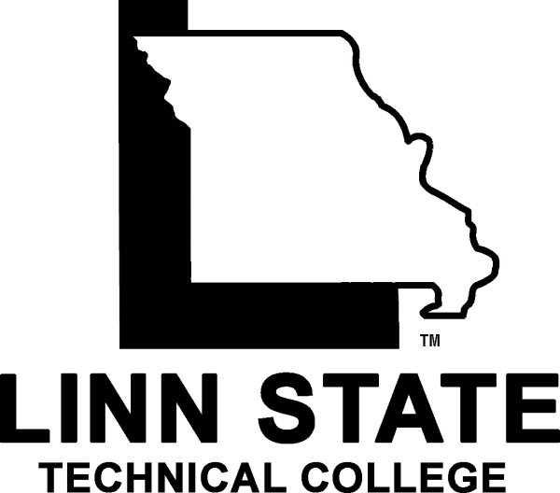

Dual Credit
Guidelines

LSTC Dual Credit Purpose
Dual credit at LSTC enables high-performing junior and senior high school students the opportunity to simultaneously receive credit towards high school and college-level course work. The program strives to challenge superior high school students who have mastered or nearly mastered the complete high school curriculum by enhancing course work through the introduction of college-level course work. Successful completion of dual credit courses accelerates student progress, reduces college costs, and avoids duplication of course work.

LSTC’s dual credit courses are taught by full-time college faculty or by qualified, approved high school faculty, supervised by LSTC. Courses are offered on an LSTC campus, at the participating high school, or via interactive television. All faculty, whether full time or adjunct will meet the qualifications required of the Coordinating Board for Higher Education (CBHE).

The LSTC Dean of Academic and Student Affairs is responsible for certifying to the CBHE that LSTC is in full compliance with CBHE dual credit guidelines. Compliance with CBHE standards ensures the transferability of LSTC dual credit coursework to other Missouri institutions in the same regard as non-dual credit coursework.

Student Eligibility
To be eligible to participate in the LSTC dual credit program, students must meet the following minimum criteria:
- Meet a minimum of a 3.0 (on a 4.0 scale) or the equivalent
- Be recommended by the high school principal or his or her official designee
- Meet equivalent admission requirements for individual coursework as non-dual credit students

Program Structure and Administration
- Dual credit courses offered in participating high schools will be equivalent to non-dual credit course content and course requirements. The syllabus, textbook(s), teaching methodology, student assessment strategies, and standards of evaluation will be consistent on campus and in participating dual credit classrooms.
- All high school students must meet the same course completion requirements as non-dual credit students.
- Enrolled students are required to adhere to the dates established by LSTC for registration, drop, withdrawal, or refund.
- LSTC dual credit students have available access to on-campus support services, including library services on-campus and online and learning support services.

Faculty Qualifications and Support
High school instructors of dual credit must meet LSTC instructor requirements as stipulated for accreditation by the Higher Learning Commission.

Partnering instructors teaching general education courses must have a master level degree or a minimum of 18 graduate hours in the content area in which they are teaching.

Supporting documents required of participating dual credit instructors:
- Official transcripts including all attended institutions,
- Completion of the LSTC Application for Employment, and
- Resume

Partnering instructors are assigned to the appropriate LSTC department chair to provide instructional expectations, best practices, assessment, and evaluation ensuring the course work being taught by the partnering instructor is equivalent to the course work taught by LSTC faculty. In addition, participating dual credit students complete a “Student Evaluation of Instruction” where the results are discussed with the dual credit instructor.

Students evaluate dual credit participating instructors according to the same schedule and procedures used for LSTC faculty.

Assessment of Student Performance
Dual credit instructors will be provided with the same syllabus, textbook(s), teaching methodology, and student assessment strategies as used on-campus. Accordingly, equivalent testing procedures and evaluative assessment measures will be administered for dual credit courses as non-dual credit courses, which will be monitored by the appropriate LSTC department chair.

Student performance reports will be submitted annually to the LSTC Dean of Academic and Student Affairs for both review and consideration of continuation

Transferability of Credit
LSTC dual credit coursework follows the same curricula as non-dual credit coursework; therefore, deemed equivalent. College credit for dual credit classes will be awarded at the end of the semester in which the class is completed.

LSTC will accept without limit transfer dual credit coursework completed at other colleges and universities from institutions adhering to the CBHE dual credit guidelines as long as:
- the credit meets a graduation requirement,
- the student earns a grade of “C” or better, and
- the student meets the LSTC residency requirement (for details, refer to the current LSTC catalog).

For a student to receive LSTC credit, the Office of Admissions must receive an official college transcript mailed from the college or university granting the credit. Required course equivalency will be evaluated on a class-by-class basis.

It is the responsibility of the student to check with respective colleges and universities regarding the transferability of LSTC dual credit courses.

LSTC Dual Credit Course Registration Instructions
To apply for dual credit admission, students must submit the following information to the LSTC dual credit contact:
- Linn State Technical College Easy Enrollment Application for Admission
- LSTC Dual Credit Permission Form
- COMPASS or ACT scores
- Official high school transcript
- FERPA Financial Release Form
Dual credit admission decisions are based on the current admission policy and are in accordance with the college’s standard practices on equal opportunity.

For More Information
Whether you are a high school interested in parting with LSTC to provide dual credit opportunities to your students, or a high-performing student who would like to accelerate your academic progress, or an instructor who has questions regarding becoming a partnering instructor, please contact us!

Dual Credit Contact:

Kristan M. Hassler
Academic Support Assistant
One Technology Drive
Linn, MO 65051
Phone: (573) 897-5114
Fax: (573) 897-5036
Email: kristan.hassler@linnstate.edu

